ITEC3250

Assignment 4

100 pts

Due 10/15

Dr. Jonathan Jenkins
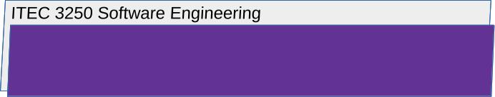

Answer the Following Questions

4 Part 1 Software Testing, with Textbook Chapter 8

- For the following numbered cases, argue whether program source code inspection by human engineers or formal software testing should be used to discover and fix the issue
  - A software system is designed to rank job candidates by processing resume information. This system is currently producing incorrect categorizations and rankings that do not match the hiring organization’s requirements.

- This, to me, seems like it should be handled by a combination of source code inspection by engineers and by using software testing. The engineers should be able to see the issues and figure out where in the code that the issue lies. Using their debugging skills to trace the flow of execution will allow them to find where the errors are. They can then change the code and do preliminary testing. However, there are a lot of cases. An engineer may not be able to cover every case, and testing will be time consuming. This is where software testing comes in. It can automate repetitive tasks and execute them quickly. It can also cover a wide range of input data and scenarios, testing each. Finally, formal testing is easily reproducible, allowing test results to be compared to find any further issues. Engineers and formal testing should be able to work together to deliver the best possible product.

5 Part 2 Software Evolution, with Textbook Chapter 9

- Suppose that the job candidate ranking system described above has completed development, testing, has been deployed for use in real organizations and completed a few years of maintenance. However, competition from artificial intelligence-based tools has recently appeared.
Briefly argue which of the numbered options given below (or a combination?) is the best choice for the evolution of this software system.
Support your argument with factors discussed in the chapter
Review textbook chapter 9, section 9.2.1
  - Scrap the system
  - Continue with regular maintenance
  - Reengineer
  - Replace all or part of the system with new code.

- I would say that a combination of reengineering and replacing part of the code would be the best option. I would begin by assessing the system’s performance, finding where it could be improved, and determine which AI tools could improve it. I would focus on areas where AI would provide the biggest benefits, like language processing, candidate matching, or data analysis. I would then implement changes in phases, which would minimize disruption and allow for testing and for the engineers to fix any issues that may arise. After all of the changes are implemented, the system should be continuously monitored. Regular performance assessments and adjustments would allow the system to remain relevant and effective.

